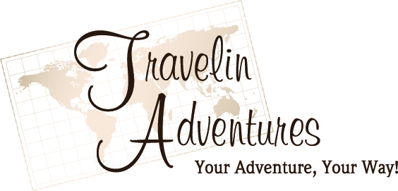
Credit Card Authorization Form

Date:_____________________________

Agent Name: Wendy Burrows Agent ID: 20028378

I, _________________________________________________________

authorize Travelin Adventures to charge the amount of

$______________ for the following services:_______________________

___________________________________________________________
to my: (circle one) Visa MasterCard American Express Discover

Card # _____________________________________________________

Exp. Date: _______________ CCV/CID# _____________

(exact name as it appears on credit card)
VISA, MASTERCARD, DINERS & DISCOVER credit cards have a three-digit (CVV)
number. It is printed in the signature panel on the back of the Visa, MasterCard and
Discover cards. The verification number is the last 3 digits on the right side of the panel.
AMERICAN EXPRESS credit cards have a 4 digit non-embossed number. It is printed
above the account number on the front of your card. It may appear to the left or to the
right, but it is always above your account number.
DEBIT CARDS or if your card has no verification code, enter 0000 in the CVV/CID field.

Billing Address: This must be the address where your statement is mailed.

Street ______________________________________________________

City: __________________________ State ___________ Zip: __________

Cardholder’s Signature: _________________________ Date: ___________
I/we are aware of any cancellation policies and agree not to dispute or attempt to
chargeback any of the above signed for and acknowledged charges.
_____________
(cardholder initial)

